Chain of Jewels

Equip yourself with powerful gear and strategically combine Attacks into chains to create devastating combos, beat enemies, and win loot to craft yourself the ultimate warrior!

Core Loop

Earn Materials > Craft Equipment, Jewels, Chains, and Attacks > slot equipment with Jewels (outside of combat) > Select Levels and set up optimal Attacks and Chains to win > Earn more Materials

Chapters

There are 5 chapters, each area with different themes and matching enemies. There might be a new mechanical gimmick for each chapter which goes along with the theme.

Each chapter has its own Mario 3 style map with each fight represented by a node. There might be a couple divergent path choices, but mostly each fight is done in a linear order.

Difficulty level: There are normal and hard paths with different loot. The normal difficulty path might have a couple offshoots with special loot at the end.

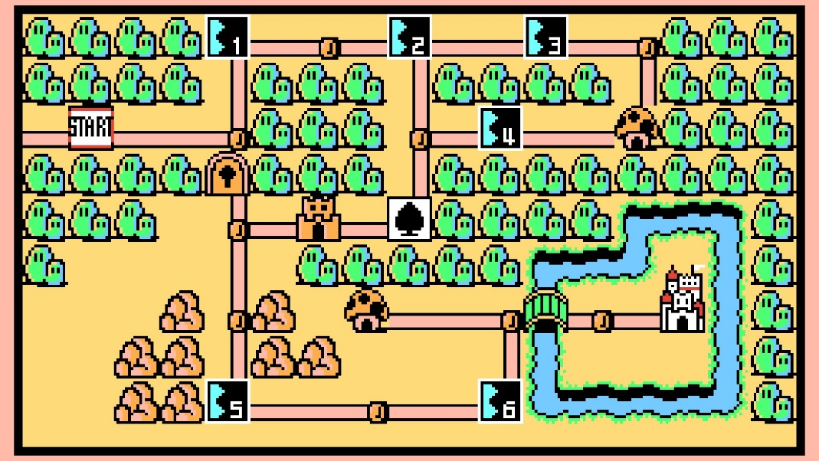

You have to defeat the entire chapter on normal before the hard path is unlocked. The hard path is about as difficult as the next chapter content so a player can jump back and forth between chapters. At the end of the hard path is lots of loot and a recipe for upgraded character equipment which is superior to the next chapter's basic gear.

The final boss challenge for each chapter is only unlocked after you compete all hard mode paths and then each boss after the first requires the last chapter boss to be defeated. This is a single difficult boss challenge per chapter. The best endgame Jewels and loot drop from these challenges. The game is "beaten" when the chapter 5 final boss is defeated.

Ratings
Depending on how much damage the player took during a fight, they are given a "rating." The better the rating, the more loot boxes they get.

An "S" rating unlocks Auto Complete. This is where the player can hit a button to automatically do the mission for a small amount of stamina. Generally it's not worth it at higher levels.

Fighting

Before a fight you decide the order you are going to arrange your Attacks using chains and then watch the fight automatically progress based on your predetermined actions.

Here is the flow of a fight:
1. Select the level
2. Drag and drop Chains onto the queue (these are a bit like blueprints to place your attacks in)
3. Drag and drop Attacks onto the chains
4. Press go (spends stamina to start the attempt at this point) and watch how the fight goes
5. Adjust your strategy and maximize your points through careful arrangement of Attacks and chains

There are three types of Attacks:

Set-up (S): attacks that give the next attack bonus damage.
Direction arrows (right, left, up, down): Most Attacks will be direction ones, used in chains.
Follow-up (F): does more damaged based on the attack done before it

Example chain: Triple fire flurry: (Setup) (Right) (Right) (Left) (Follow-up) - grants you +50% damage and adds the "fire" tag to all your attacks.

There are a collection of "tags" that certain enemies might be weak/strong against: Pierce, Poison, Fire, Electricity, Metal, etc.

Effective = +25% damage
Ineffective = -25% damage

Levels might have challenges like your second slot is blocked off preventing certain combos. You might be limited in how many Attacks you can equip. You might only be able to take set-up Attacks to this fight or the enemy can only be hurt by damage over time effects, etc.

Loadouts

Each level requires the player to set up their Attacks for the fight as each fight has different challenges, but they can favorite certain chains to make the process easier. Each level will remember the previous loadout used so players can continue to easily refine their loadout for maximum score.

Stamina

The enemy will attack dealing damage to the user's stamina after every complete chain, the faster you defeat the enemy, the less stamina you lose and the higher your rating. The better your rating you get the better your drops.

Starting a level takes a small amount of Stamina, but the vast majority of it will come from being damaged by enemies.

You can eat food or simply stop playing to slowly regain stamina. Staying at the inn (watching a video) will refresh a decent amount of stamina. Food may be bought with soft currency, won in a roulette, given as a sign-in gift, given as an achievement, etc.

Max stamina can be increased by slotting better jewels in your armor.

Chain Book

Compendium of all the Chains you've crafted. Recipes the player doesn't own do not have any details other than how to earn the recipe. The percent of recipes owned are visible to encourage completionists to make all the chains and complete their chain-book.

There is also a tab for every Jewel/Attack in the game and a percent of the Jewels/attacks earned. Jewels and attacks need to be sorted by type and set and also tell players how to earn any unearned Attacks and Jewels

Crafting Gear

There are two gear sets per chapter, a normal one you can get from normal difficulty levels and a hard one with unique abilities you get from grinding the hard difficulty path for the chapter, which can be upgraded to end-game levels. They distinguish themselves by aesthetics and their unique ability/bonus.

Each chapter has these materials:
- Normal generic material
- Normal weapon material
- Normal armor material
- Rare generic materials
- A tier of paper for chain recipes

Each craftable item requires a recipe. Normal weapon and armor recipes are granted at the start of the chapter. Rare weapon and armor recipes are a drop from the hard boss for the chapter.

Ex. Iron Armor
Recipe: 5 iron plates, 10 second tier magic essence, 5000 soft currency
Stats: 9 jewel slots in a 3x3 grid (like below)
Bonuses: Blue bonuses grant 5% bonus to stamina per, red grants 10 additional stamina per, and purple grant +1 stamina a turn per completed bonus.

As weapons and armor get better they get more Jewel slots and might have special bonuses if they are the hard path equipment.

Equipment Jewels

Jewels on weapons and armor are arranged in a grid which determines if they get any bonuses. Each equipment Jewel has an indicator on one of it's sides or corners. When placed next to a jewel that has the same indicator on the side boarding it, the bonus is complete and the player enjoys some kind of benefit based on the equipment it's slotted into. This means all jewel slotting on equipment is a bit of a puzzle for the best combination (like kingdom death, see below).
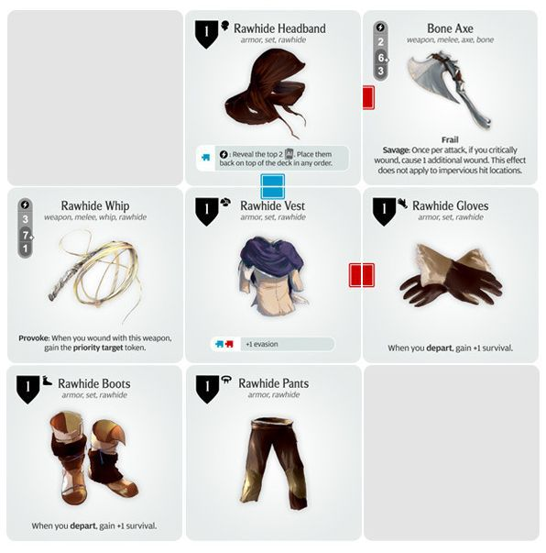

Jewels on weapons are generally damage based bonuses and Jewels on armor are defense and stamina based.

Crafting Chains
Chain recipes are randomly dropped. Once obtained they won't be dropped again. Unique chains might be dropped in limited time events.

The crafting recipes are generally some combination of tiered paper crafting materials and combat Jewels.

Chains are used when a player is setting up their combat Jewels to give massive chain bonuses. They require that the combat jewels have the right combination of shapes, similar to a fighting game button combo.

Obtaining Jewels and Attacks

There are two kinds of jewels: weapon and armor. And there's three types of attacks, set-up (S), arrow (right, left, up, down), and follow-up

You can earn Jewels and Attacks in many way:
-Drop- from doing chapter missions and getting drops
-Reconstruction -smash for special resource to buy common jewels or craft specific reconstruction Jewel sets
-Recipes
-Buy with Soft currency
-Buy with Hard currency
-Buy with PvP currency
-Sign-in Bonuses
-Roulette Wheels with free daily spins (can pay for more)
-Offer packs
-Events

Attack Example
Name: Wild Swing
Type: (Up arrow)
Damage: 125
Effect: DoT 3 rounds, 10 damage
Tags: Metal
Ratity: ***
Set Bonus: Wild - +5% damage for every other "Wild" Jewel.

Armor Jewel Example
Name: Hunker Down
Type: blue (left side)
Stamina: 20pts
Rarity: **

Directions are randomly assigned, but can be reforged by either spending hard currency or feeding it resources made from smashing up jewels.

Deconstruct

You can “deconstruct” unwanted Jewels and Attack Cards for special deconstruction currency which you can use to buy exclusive sets of Jewels and Attack Cards.

Reforge

You can “reforge” Jewels to reroll which side their bonus colors will be on or “reforge” Attack Cards to change which direction their arrows go. The reforge costs soft currency and crafting materials and the end result is random (although it WILL be different than the current Jewel or Attack Card).

Evolve

You can combine multiples of the same Jewel or Attack Card to get a stronger version of it!

Pvp

Players can compete with other players by setting up for a specific challenge and seeing if they can get a higher score than other players. The PvP level changes daily (7 challenges, one for each day of the week) and they get 5 free attempts a day; more attempts can be bought with premium currency. Wins grant the player 5 pvp points and losses give them 3 points. They can use these points to buy an exclusive PvP Jewel sets and Attack sets.

At the end of the weekly reset, players are given additional rewards based on their performance in the last week. Players are given generous rewards for participating at all in PvP and at each tier (top 50%, 20%, 10%, 5%, 1%, and top 100) they are gifted even more rewards. once a player hits a tier, they are guaranteed the reward even if they drop below it.

Achievements

Daily achievements encourage the player to do the core game loop every day for a nice bonus.

Lifetime Achievements encourage the player to have long term goals such as completing attack sets, beating chapters, getting a certain amount of S-ratings, etc.

Achievement rewards can include but are not limited to soft currency, hard currency, food items, loot boxes, free roulette wheel spins, crafting materials, etc.

Roulette Wheels

Every 20 hours, players may spin a roulette wheel to receive a prize from a list of loot. Common items are dropped more often than rare and you can get repeats. Drops might include hard currency, food items, loot boxes, crafting materials, jewels of all kinds (including exclusive roulette wheel exclusive jewel sets!).

Every spin gives you a special roulette wheel currency you can use to buy the exclusive roulette wheel jewels and attacks so even if your luck is bad you'll eventually get all the exclusive drops!

Roulettes might be spun again outside of the free spin time by spending hard currency or earning free spins from achievements or in store packs.

There might be themed wheels, like the Food wheel that only drops food items or the Jewel wheel that only drops jewels.

Login Bonus

Every day the player logs in they get a reward for simply showing up. This can include almost anything in the game including hard currency. There's exclusive login Jewel and Attack sets which are extremely good, so even an unskilled player will eventually get powerful Jewels/Attacks simply for logging in and claiming them. The calendar for login gifts goes out to 100+ days, there's no penalty for missing a day. Hard currency can be spent to jump ahead on days so an anxious player can buy their way to their login gifts.

Stores

Stores are unlocked slowly as the player gets through chapter levels with each function of the store unlocking separately. This allows players to learn the new mechanic before being introduced to the next one.

Soft Currency Store: Here you can buy common jewels/attacks of all types for soft currency. This allows players to buy common Attacks of all types so players can fill in missing attacks in their chains.

Hard Currency Store: You can buy an exclusive set of rare jewels/attacks here for hard currency. Value packs are also available which include free roulette spins, food, jewels, attacks etc.

Smith - Make equipment (armor/weapons)

Jeweler - Craft jewels (armor/weapons), Evolve Jewels, Deconstruct Jewels, Reforge Jewels

Dojo - Craft attacks, Evolve Attack Cards, Deconstruct Attack Cards, Reforge Attack Cards

